Task 1

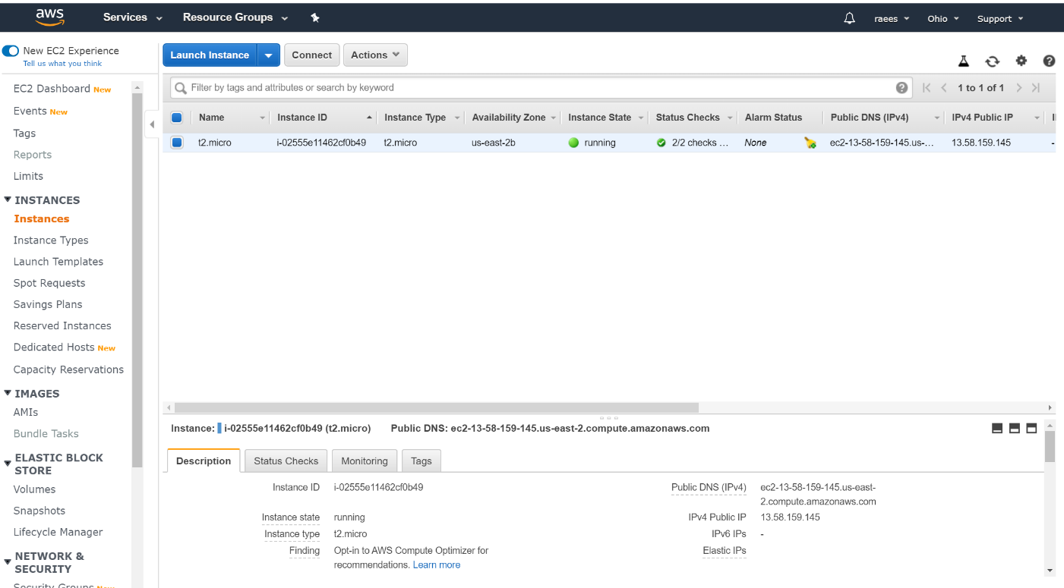

**TASK 04:**

Install Git on EC2 and Clone all your repositories separately on EC2 in the folder called “repoone2

